Reflections on Developing with SharePoint Server

We’ve been using the tickler and reporting system in SharePoint Services for about a year now. I just got Frontpage 2003 this past winter / spring, and while I’ve used it a little, I haven’t discovered how to do everything I want to do with SharePoint in it. Cloning sites is proving less straight forward than I thought it would be – it would be nice if we could go right into the SharePoint database and switch sites around and rename and duplicate them (However I have learned that copy and paste in datasheet view works pretty well when trying to populate template site lists).

But by now I have learned more about SharePoint itself. For instance, I now realize that the top menu should be an events list, not a links list. This would give us our Master Report Calendar View, which everybody could then access from their Outlook program – as opposed to my keeping a Calendar in the Public Folder on the Exchange Server which probably nobody ever uses or looks at except me.

Also changing from a SharePoint links list to an events list would make the whole system less time consuming to maintain. Maintaining the Public Calendar in Outlook was very cumbersome because of slow bandwidth (especially before SharePoint when the Outlook Calendar Entries were large). A SharePoint events list lets you create recurring events AND gives you a worksite for each instance of a report, with the option of sharing some of the webparts, such as the document library, across instances – or “meetings” as SharePoint calls them.

I’ve also had opportunity to observe what people use and don’t use in the current SharePoint system – and while I did all the scaffolding and customizing in that first go around (when I transitioned the system from Outlook to SharePoint), I’m seeing now what I can simplify, let go, and/or simply leave “as is.”

In retrospect, while it is possible to give various webparts customized titles, descriptions, and field names, in effect creating a “metaphor” specific to the application – I’m thinking now that it’s best to keep everything as generic as possible – so people can begin to learn and speak the SharePoint language to each other – so they can begin to recognize these web parts, no matter what the application, and understand what they really do. A document library is a document library, a task list is a task list – just leave the names generic and let go of all the extra descriptive stuff to fit the application. Don’t disguise what things actually are – there can be such a thing as too much scaffolding! Also keeping everything generic makes all the urls a lot more movable and portable – thereby improving accessibility. Every report site has a document library, a members list (attendees on an events work site), a compliance strategy task list, and a report procedures task list. I’m thinking I should just keep those names generic as I can – to the application and to SharePoint when possible.

Adding to the recommendations in the paragraph above – when we do have to customize web parts – we probably shouldn’t change their names or otherwise delete or “cripple” their existing functionality. Well, for the most part, anyway. Instead of changing or deleting standard fields or views, create new fields or views, but leave the existing functionality intact (unless, of course, you are building entirely new webparts from existing webparts). The minimal approach will enhance the longevity of the application, making it not only more usable, but also easier to maintain (since people can go in and hopefully recognize standard lists).

So for round two I’m creating the top level page to have an events list which will double as the master calendar and the top level reports menu. Here are a couple of screen shots of what that looks like:

First the Menu, which is actually a SharePoint events list:

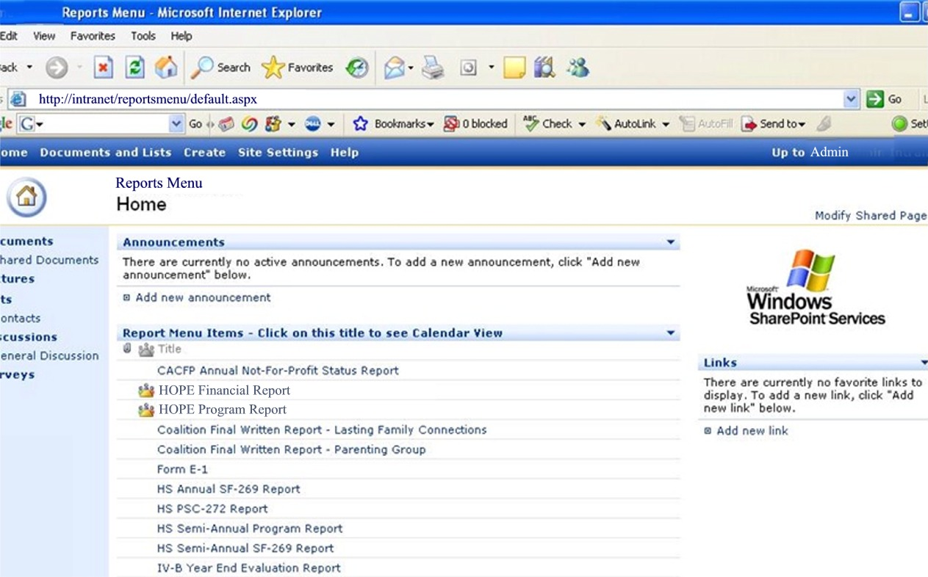

A peek at the actual event list entry:

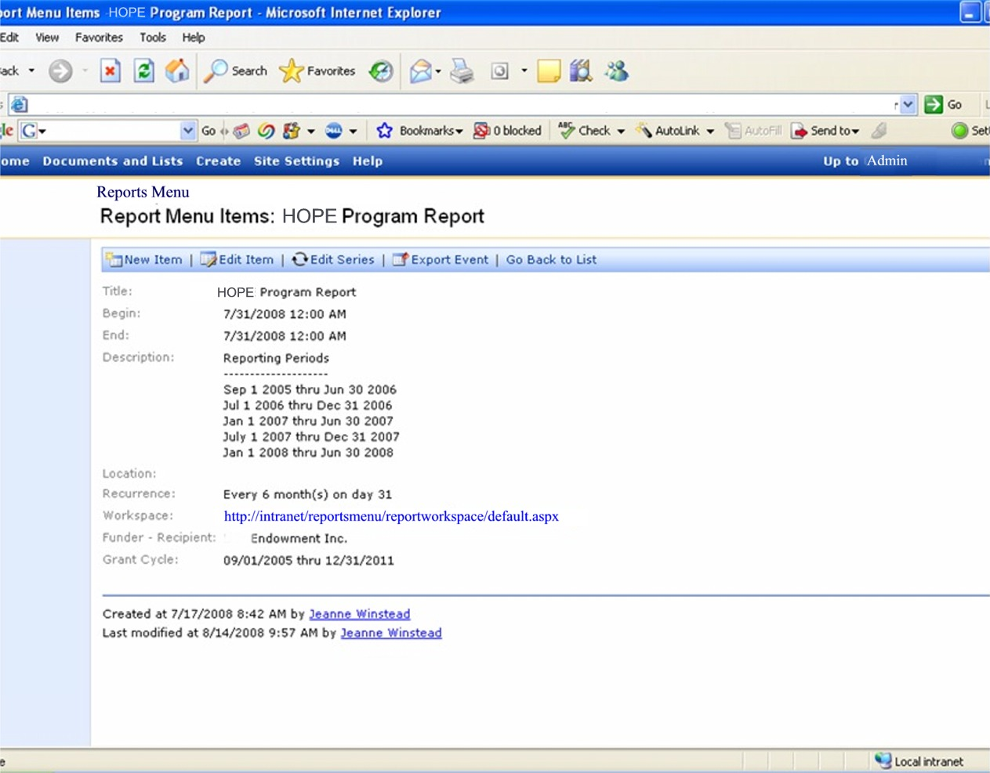

Then the Calendar View of this same event list:

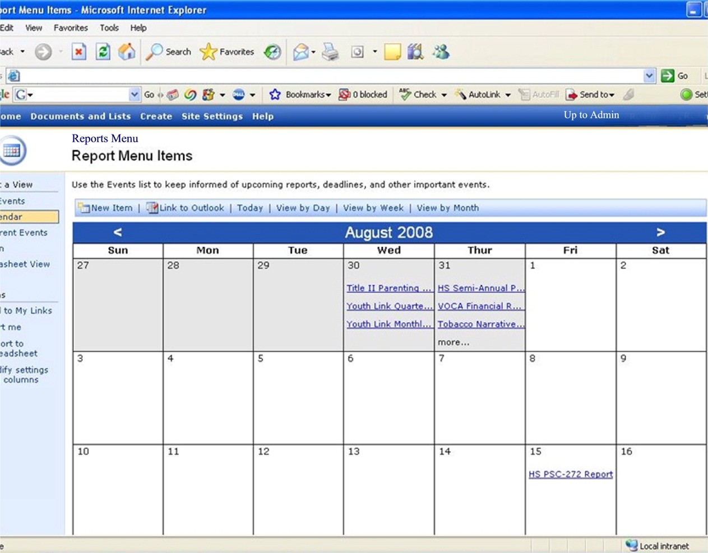

And, finally, here is how the user would see it from their own Outlook:

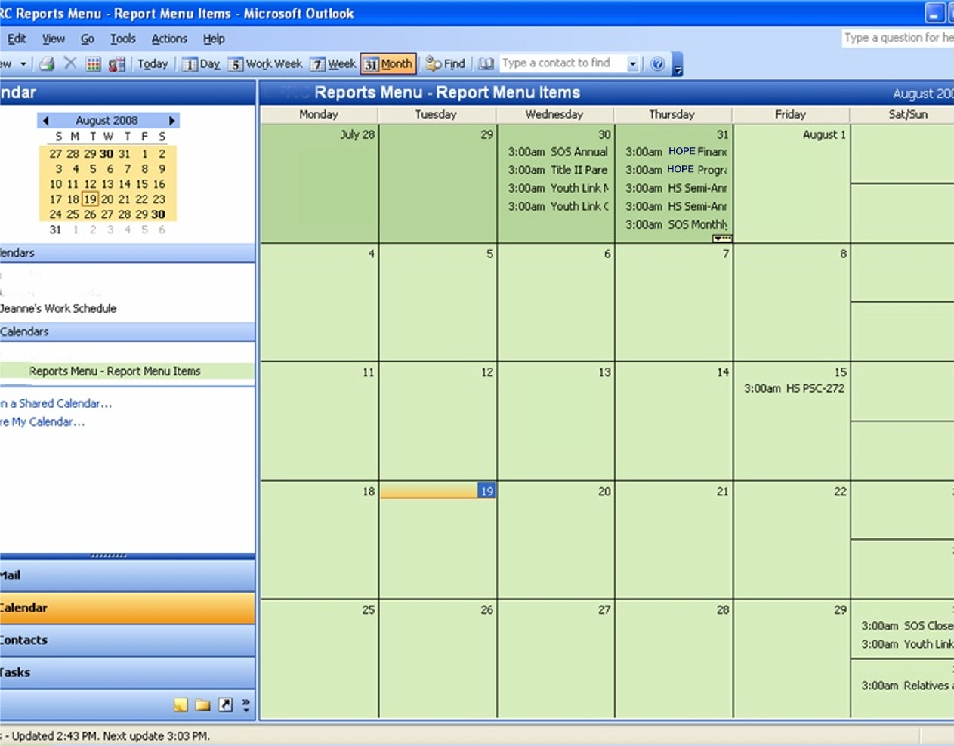
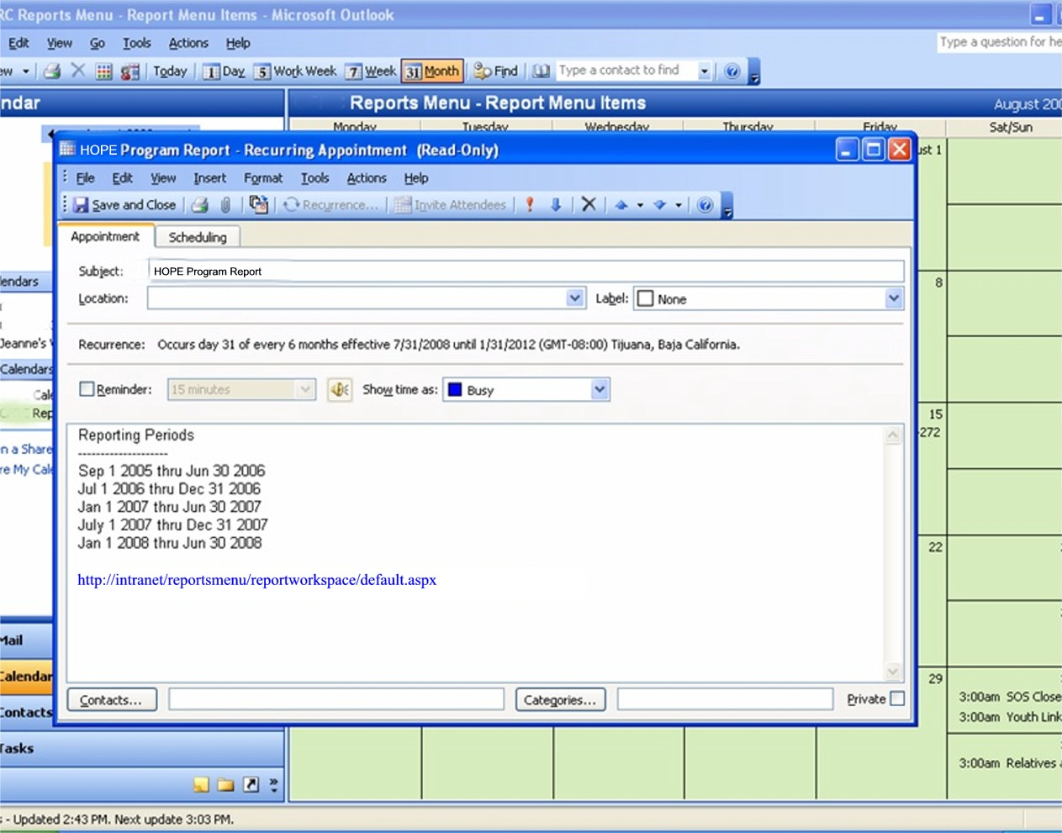

Now some screen shots of the individual report worksite. In this go around I decided to minimize most of the webparts – one, to make the page look less overwhelming to the uninitiated, and two, to hopefully get people exploring and interacting with SharePoint’s webparts a bit more – so they discover how to navigate them in various ways. Following are multiple views of the same page:
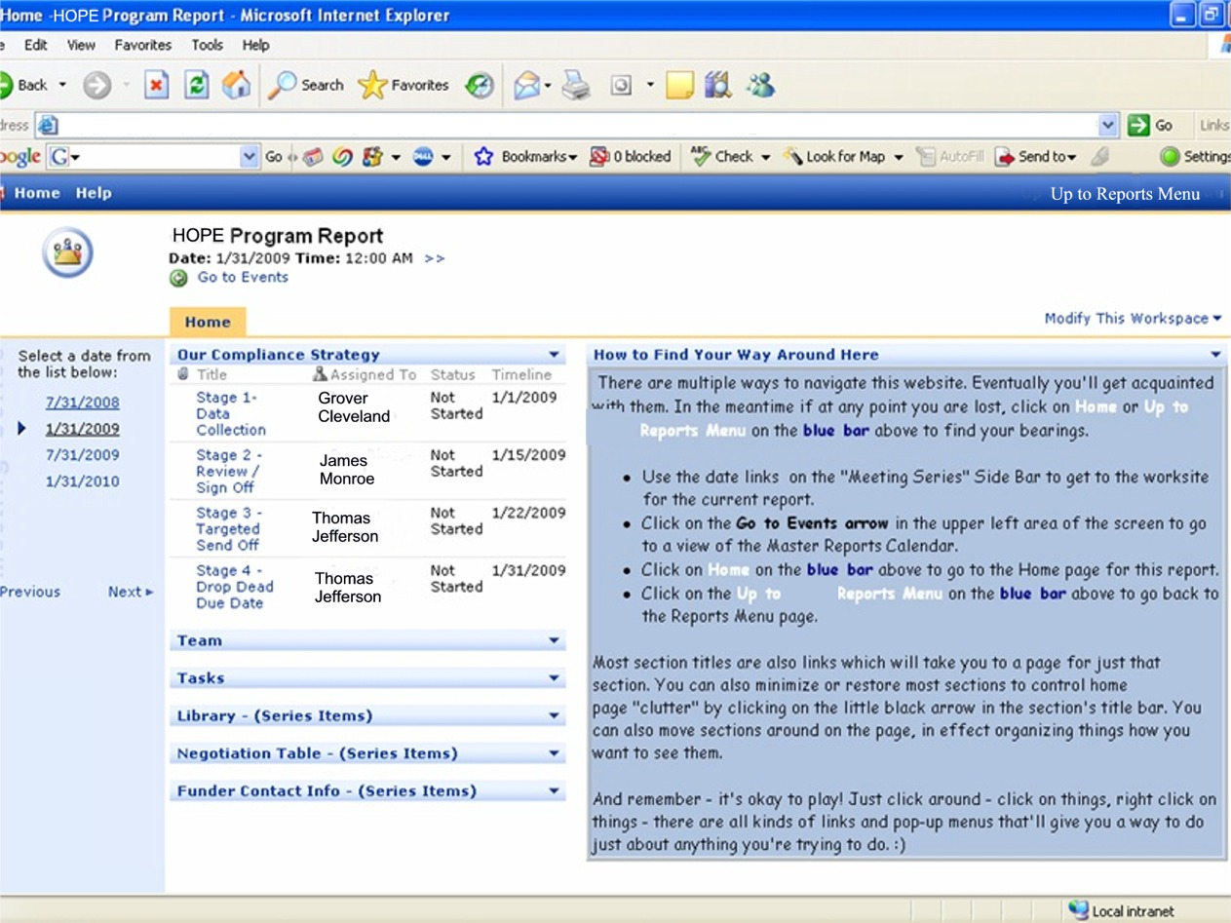
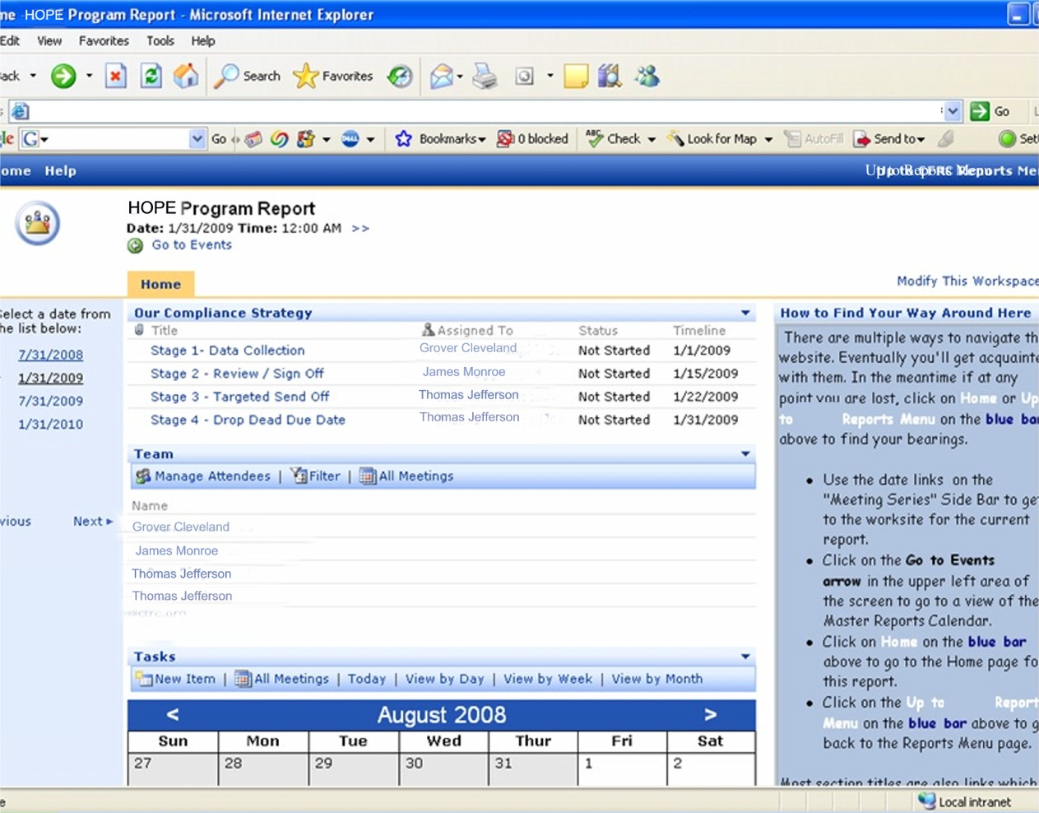
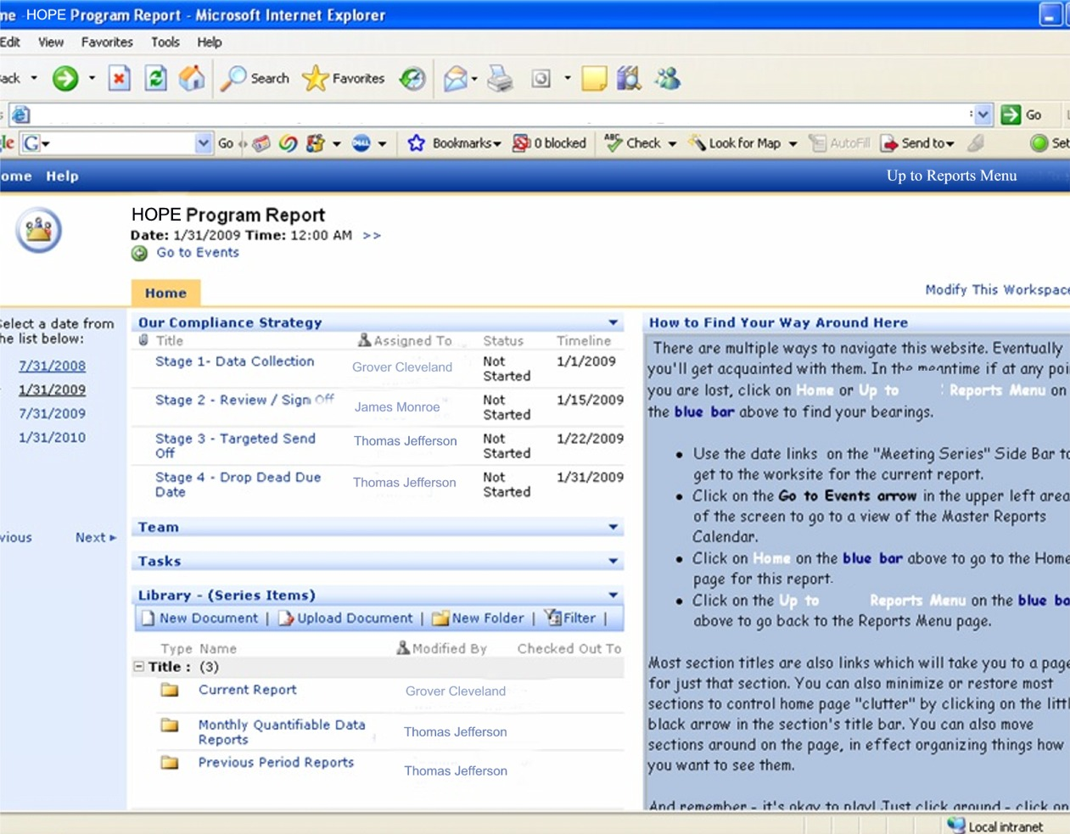
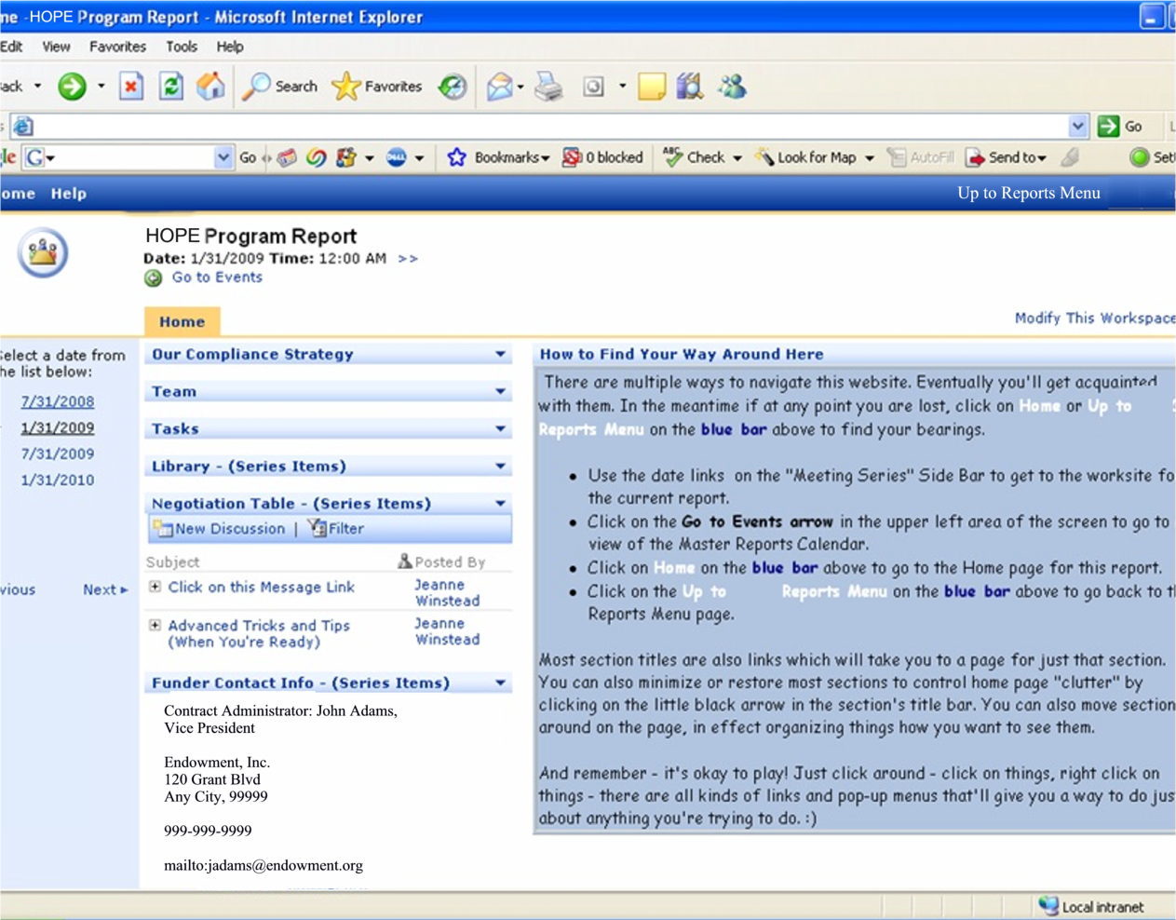

And also some views of webparts on their own pages:

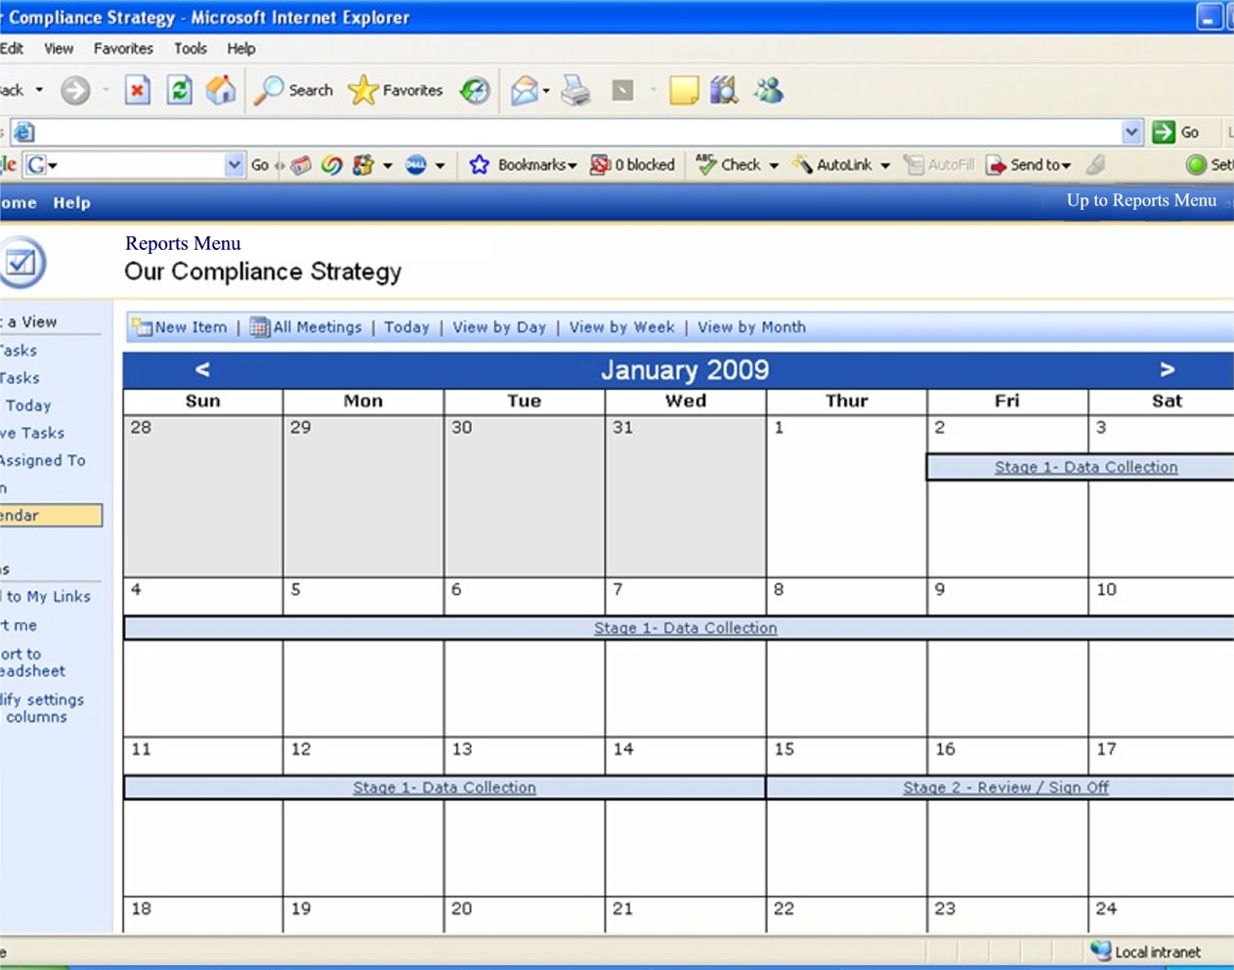
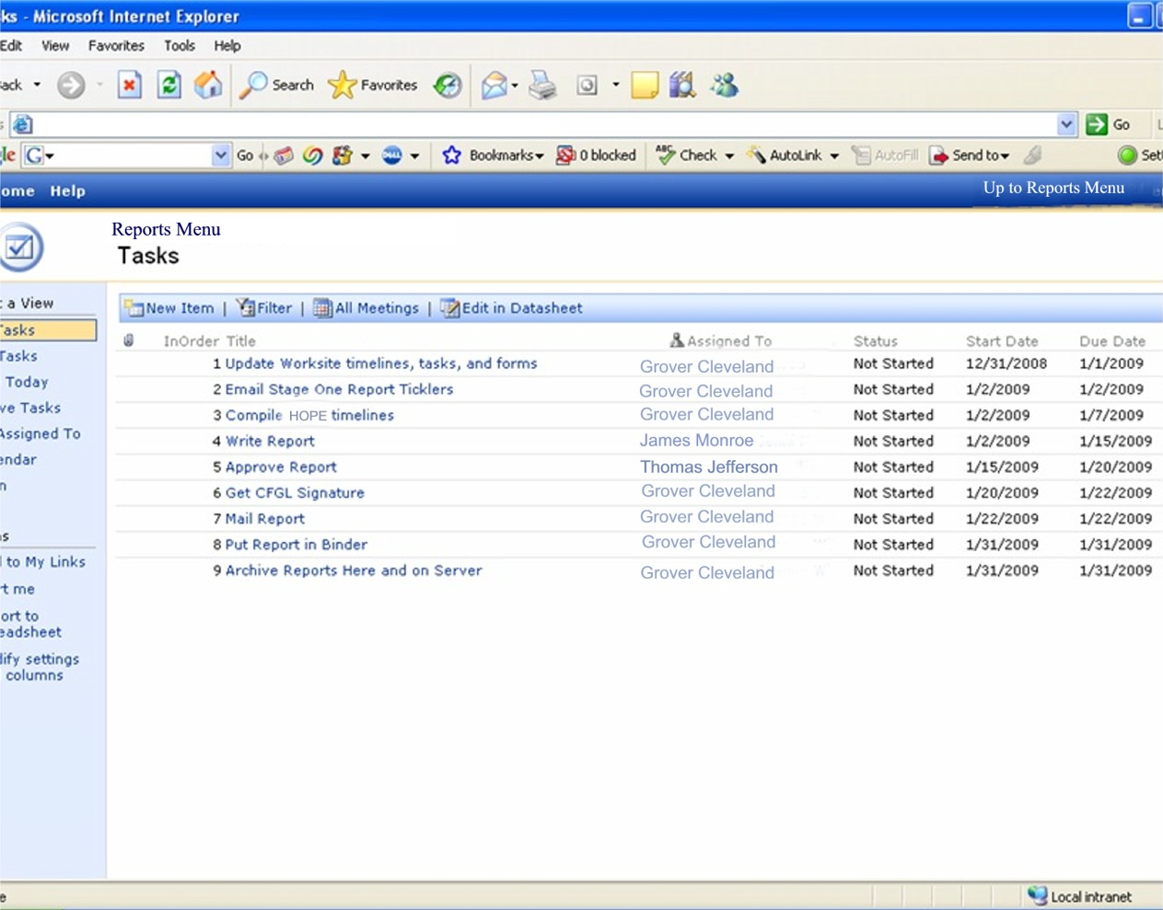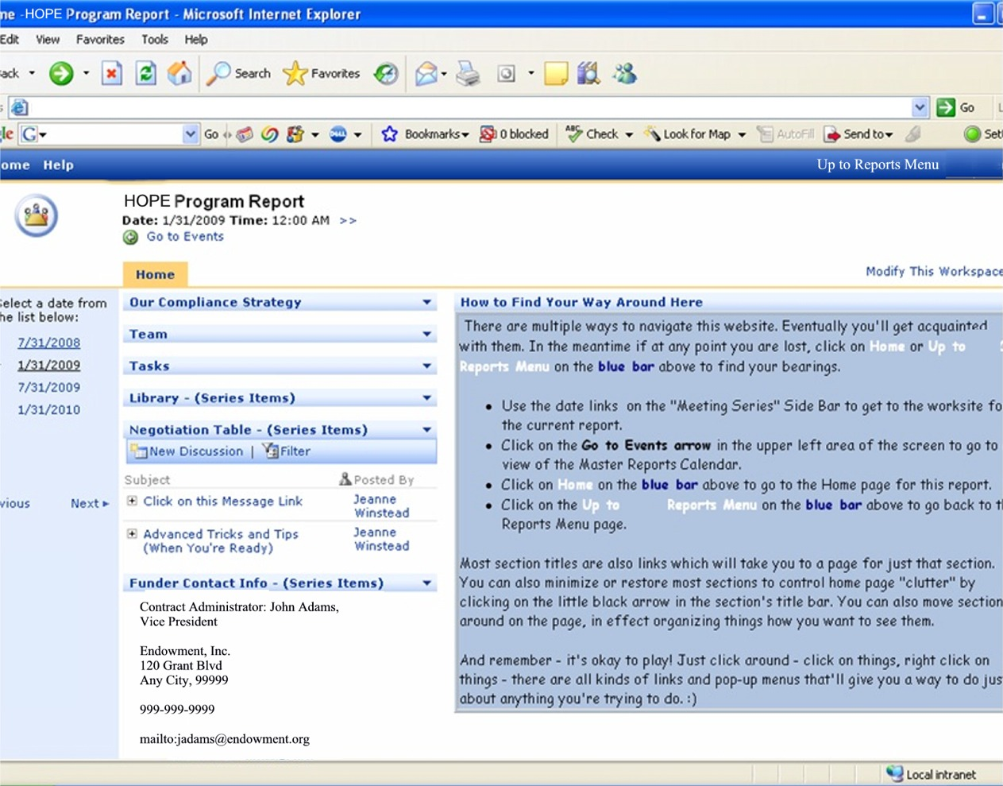

One advantage of letting SharePoint create the report worksites from an event list is that we can then have a history of when each instance of a report was actually completed and by whom.

Some Thoughts about Training …

The switch from the Outlook Tickler System to the first SharePoint Report Site was all or nothing. I pretty much asked people to jump in and start swimming and stood ready with the life jackets. Albeit one of the more drastic implementation plans, it was, at the time, our only option, and it worked well enough under the circumstances. After all, most people were familiar with Web Browsers and Interactive websites like Ebay. Or so we reasoned. Since then, I’ve had opportunity to observe what people use and what they have not learned to use. The occasional opportunity to train a new staff person in SharePoint helped confirm what I already knew - namely what a difference a little hands-on, one-on-one teaching time could make. For this next go around, I want to make appointments and actually sit with people responsible for getting out various reports BEFORE I give them the URL. ☺ I’m confident we’ll both learn a lot by doing things this way.

Also, by now people have had exposure to customizable home pages and Google Gadgets that they can add or delete or move around the page. Hopefully this concept will easily transfer to SharePoint webparts.

Some Thoughts about Accessibility …

Showing most people how to set their Browsers to open up to the Intranet site has been preferable to just having them bookmark the SharePoint site in their Favorites. However, I did encounter some resistance from those who already liked the page their Browsers opened up to for various reasons. Now, with Google customizable home pages, people can hopefully keep their preferred Home Page and simply add links on it to other frequently used sites. Part of the training should consist in making sure people know they have this option and in some cases, showing them how to set this up.

